**ASSIGNMENT-26.4 :**

Implement view in hive by following the steps in the below blog:

I am considering the real estate table and creating a view named realestate_vw.

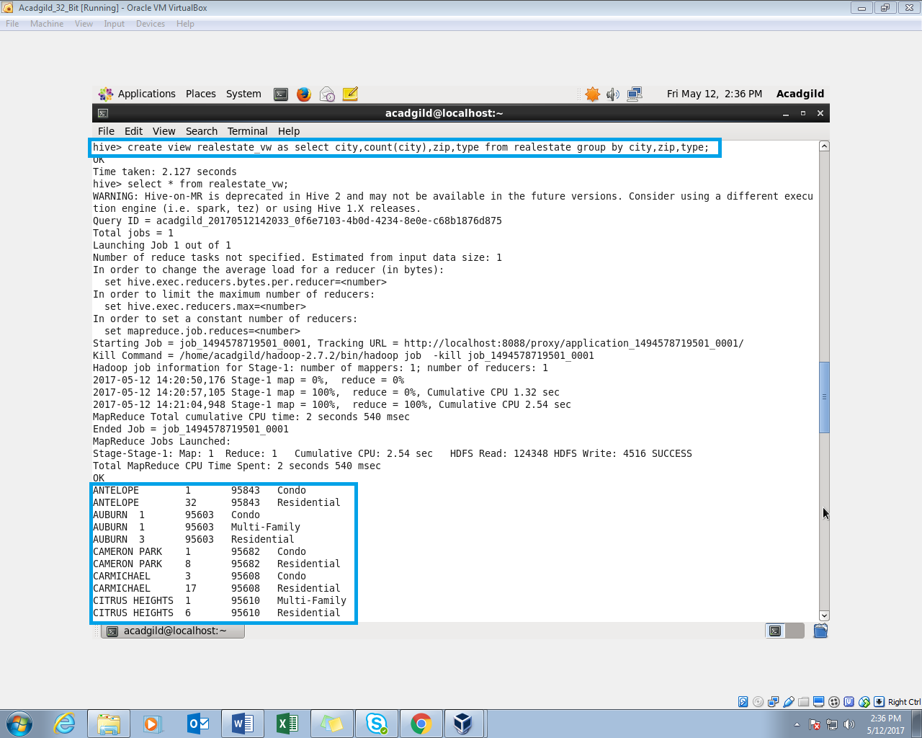

OUTPUT:

